**Third Year B. Tech., Sem VI 2021-22**

**Software Engineering Tools Lab**

**PRN/ Roll No: 2019BTECS00113**

**Full name: Sanket Rajaram Mote**

**Batch: T5**

**Assignment No 1**

1. **Weka is a GUI workbench that empowers data wranglers to assemble machine learning pipelines, train models, and run predictions without having to write code. Using Weka tool perform below tasks such as data pre-processing, data classification (use any appropriate ML algorithm) and data visualization efficiently on given dataset.**

**Use the Iris dataset given**

**https://drive.google.com/file/d/1A3Fxsfzm6BSfhFZGDrjI47RTe45bSgYP/view**

**Note-provide screen shots for every task Create a report which will illustrate the details of tasks performed (for e.g., to perform pre-processing of data provide details of navigation and selection of appropriate parameters)**

**Download and install Weka**

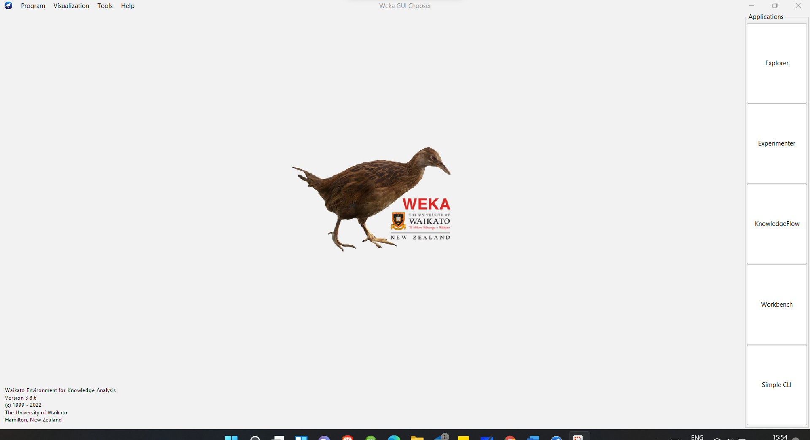

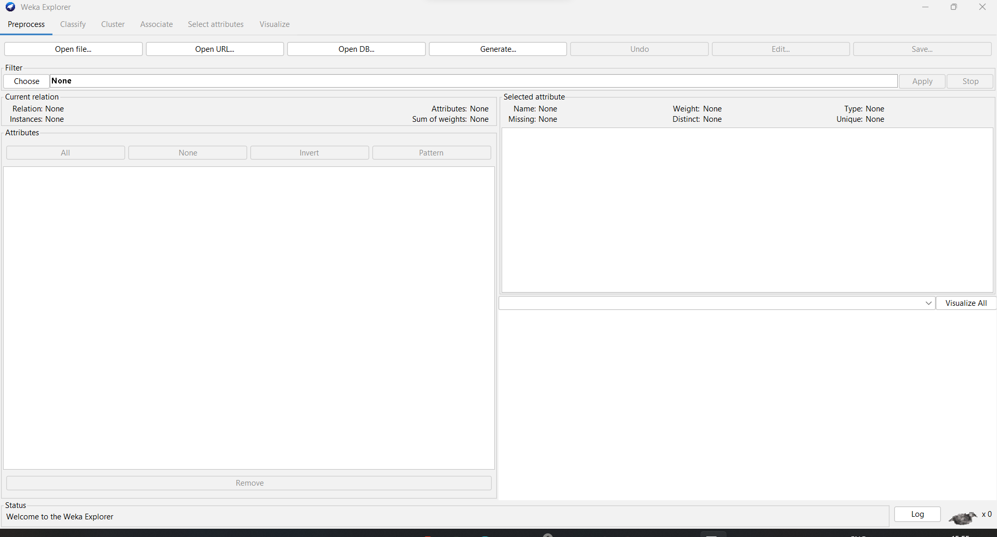

Selecting given Iris dataset: -

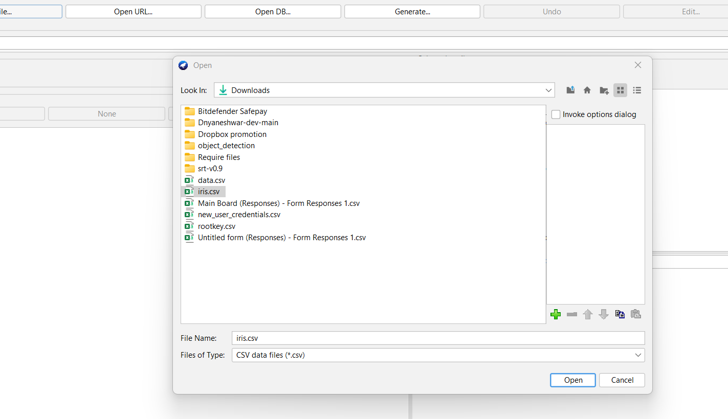

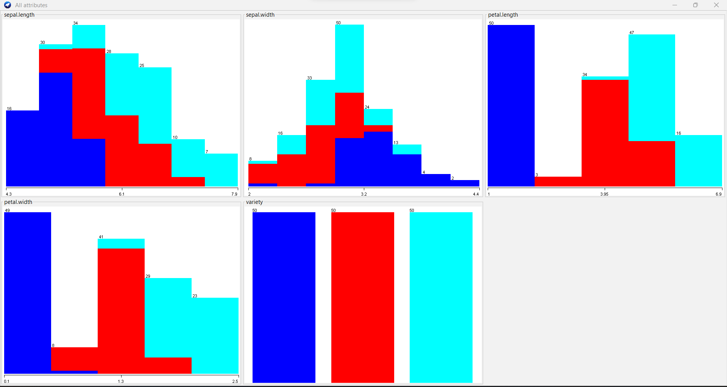

Classification:

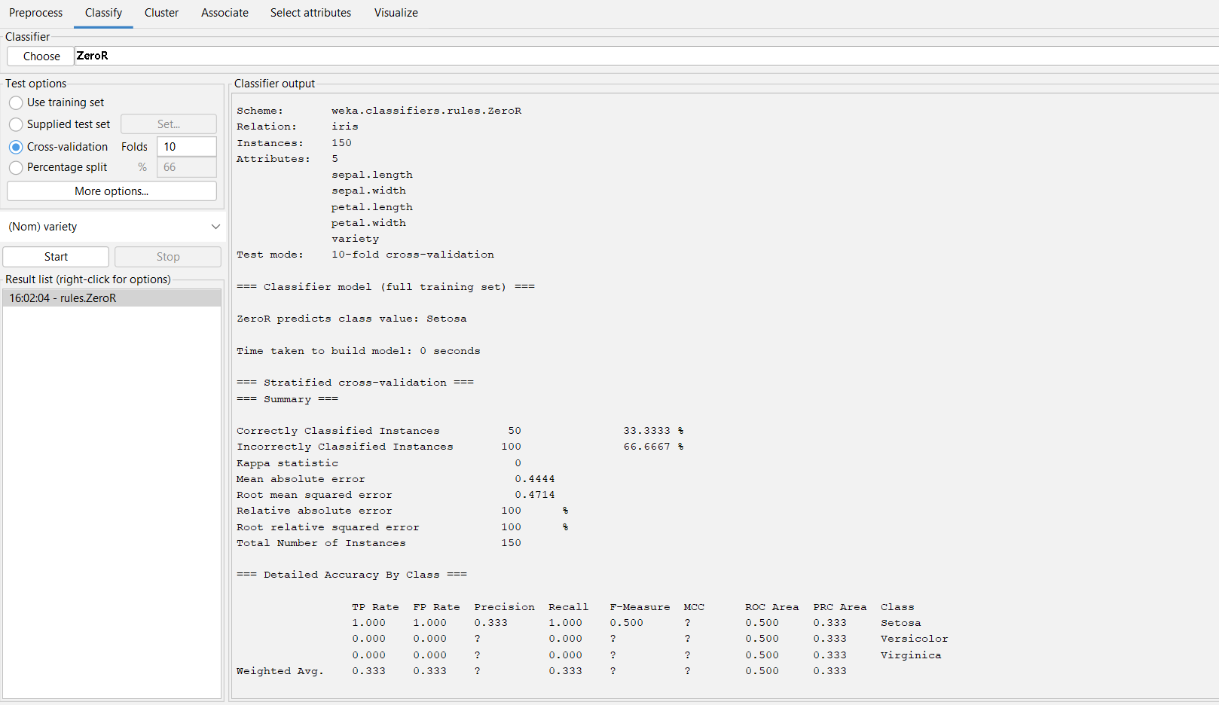

**2. Orange is an easy-to-use data visualization tool with a large toolkit. In spite of being a GUI-based beginner-friendly tool, you mustn’t mistake it for a light-weight one. It can do statistical distributions and box plots as well as decision trees, hierarchical clustering and linear projections.**

**a. Install orange**

**b. Show data distribution**

**c. Show linear projection**

**d. Show FreeViz**

**Use dataset https://drive.google.com/file/d/1m6sKI1Dap0XK6Bw1edUd5PohwpPwXnd9/view**

**Create a report for this task and upload screenshots for the same.**

Initial setup and upload data:

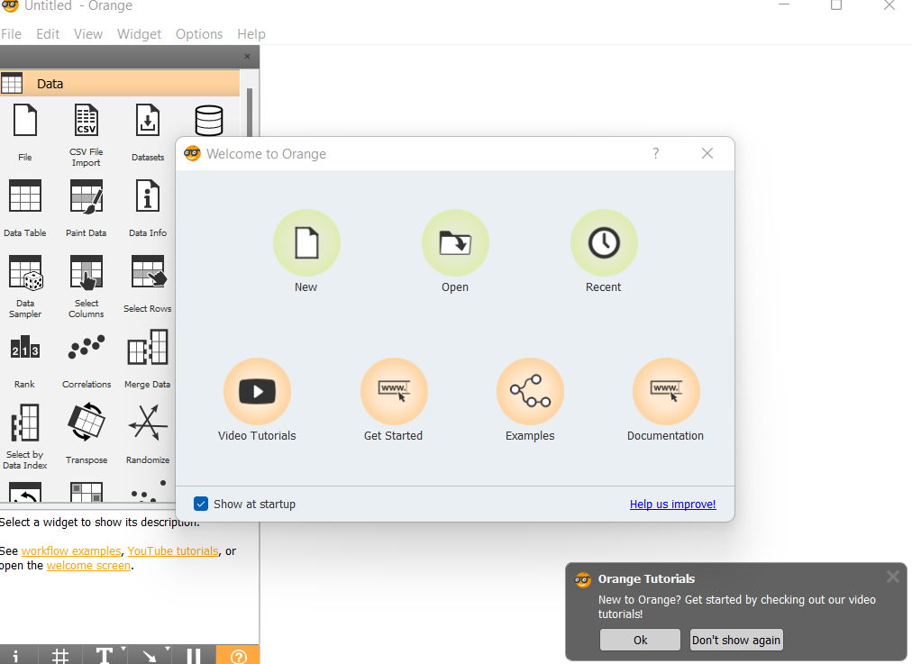

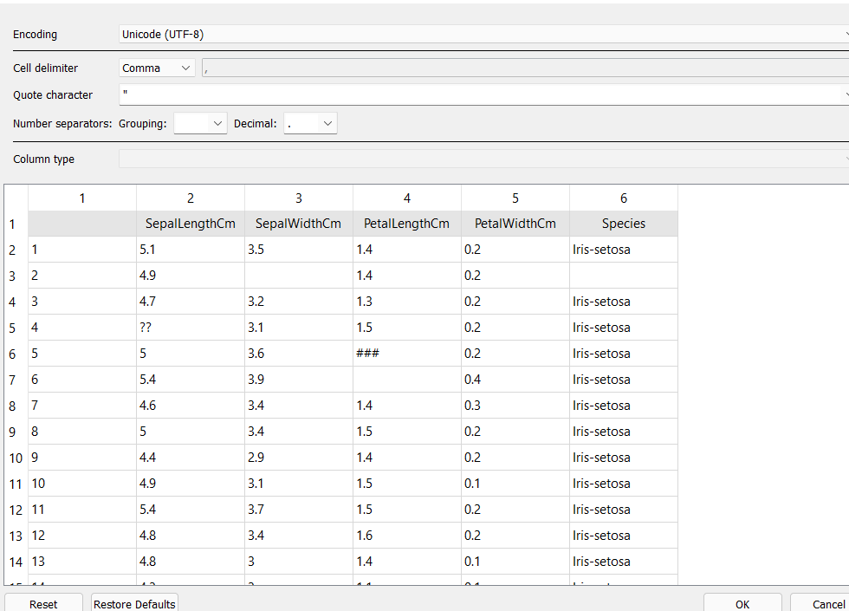

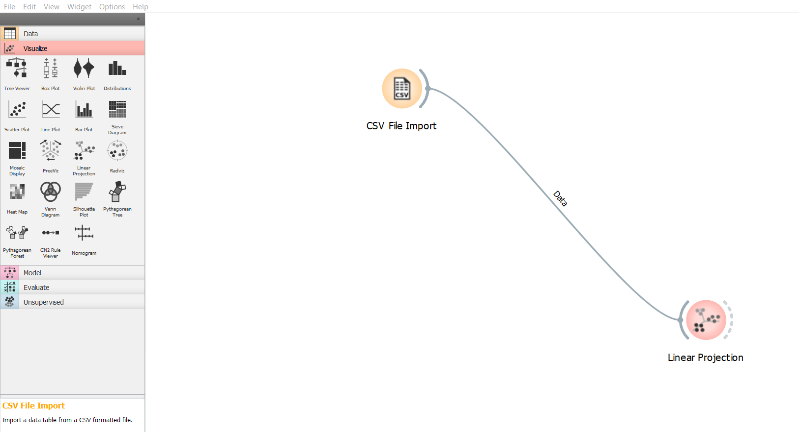

Data Distribution:

Sepal Width

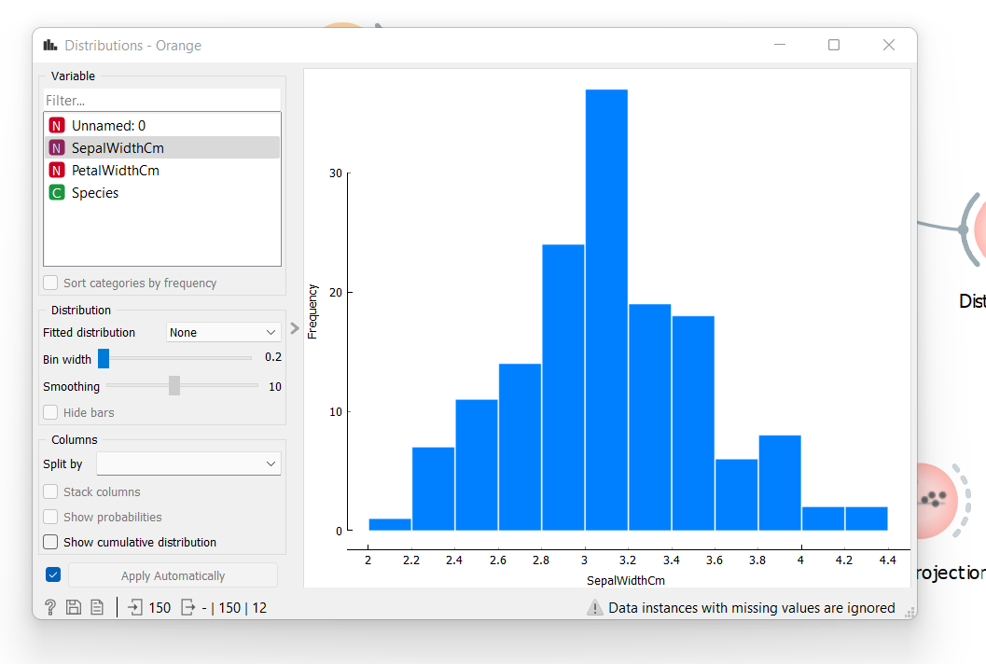

Petal Width

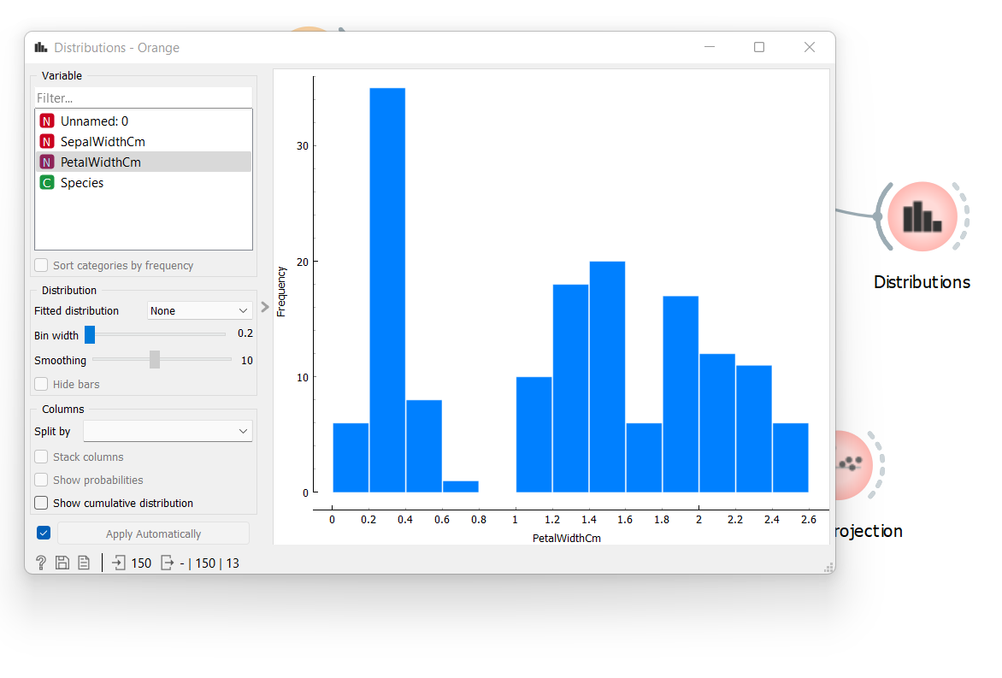

Linear Projection:

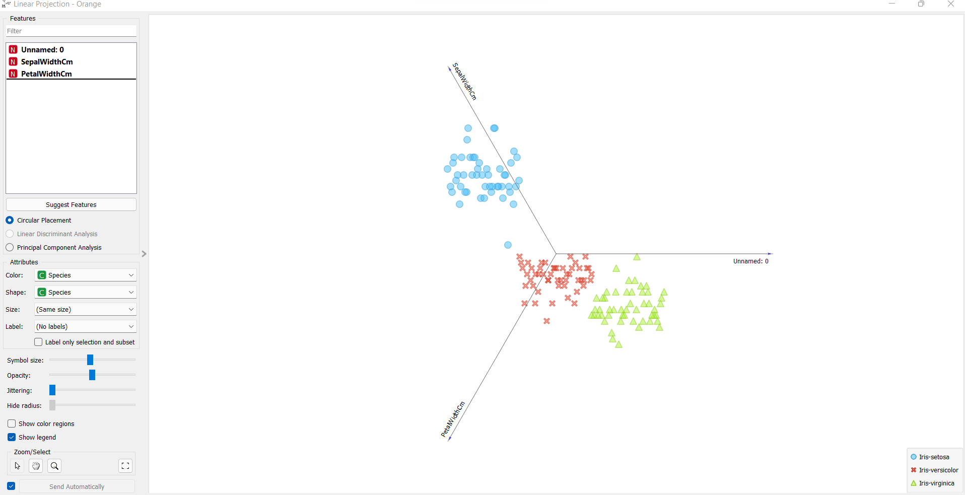

FreeViz : ( Giving Error : Data must have a target variable)

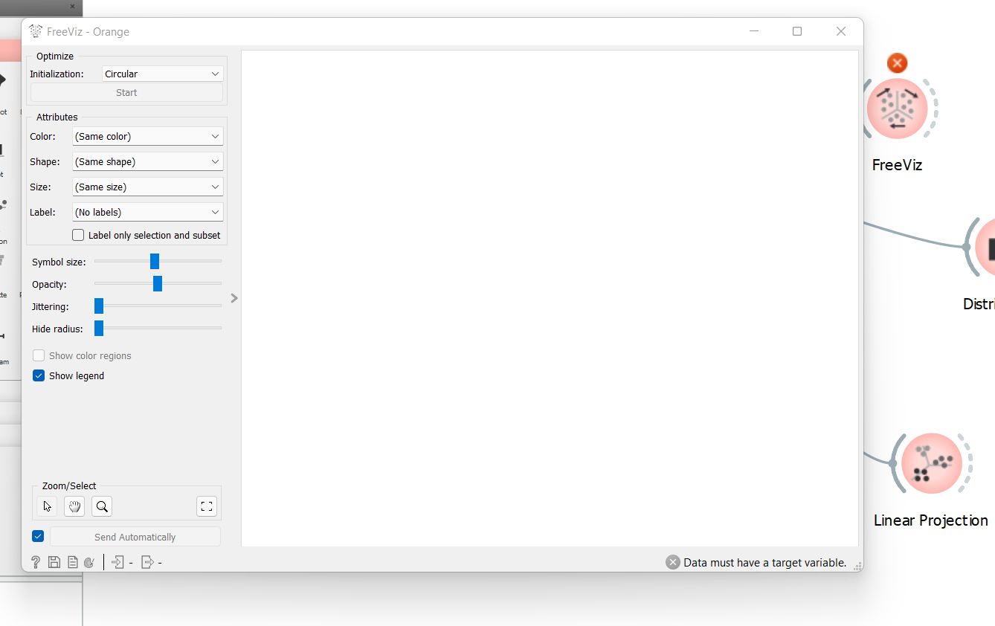

**3. Differentiate in between free software, Open-source software and proprietary software with respect to its properties.**

1. Free Software:

Free software is a computer software distributed under terms that allows users to run the software for any purpose as well as to study, change and distribute. All users are legally free to do what they want with their copies of free software regardless of how much is paid to develop the program or software

2. Open-Source Software:

Open source software is a computer software whose source code is available openly on internet and programmer can modify it to add new features remove some existing buds or problems or user might add features that he wants into that existing software without giving any money to developer. This software is managed by an open source community of developers. It provides community support for the software. All users can get this software free of cost. This software also comes with license sometimes, this license might provide some tights to user as:

• No restriction of redistribution

• User is allowed to study or modify code

• Software can be used for any purpose

Examples – Ubuntu, Android, VLC Player, OBS Studio, etc.

3. Proprietary Software:

Proprietary software is a computer software where the source codes are not publicly available and the company that has developed the software can only change the code for that software. Generally, this type of software is developed by an individual or some organizations and team inside organization works on that software for its development. If someone wants to use this type of software, he has to pay some money to the organization to buy copy of that software. Company gives license to authenticated users which has some restrictions like:

• Number of installations on different machines.

• Time uptill which software will operate.

• Number of features allowed to use.

• Restriction on sharing the software illegally.

4. Using Anaconda Python create Histogram, Scatter plot and Bar plot for the dataset given below.

**Dataset-** <https://drive.google.com/file/d/1i11BZFe8Xj9kNq7eeE9KOa_Iz1KhEdXJ/view>

1. Scatter plot- Scatter plot of Price Vs Age

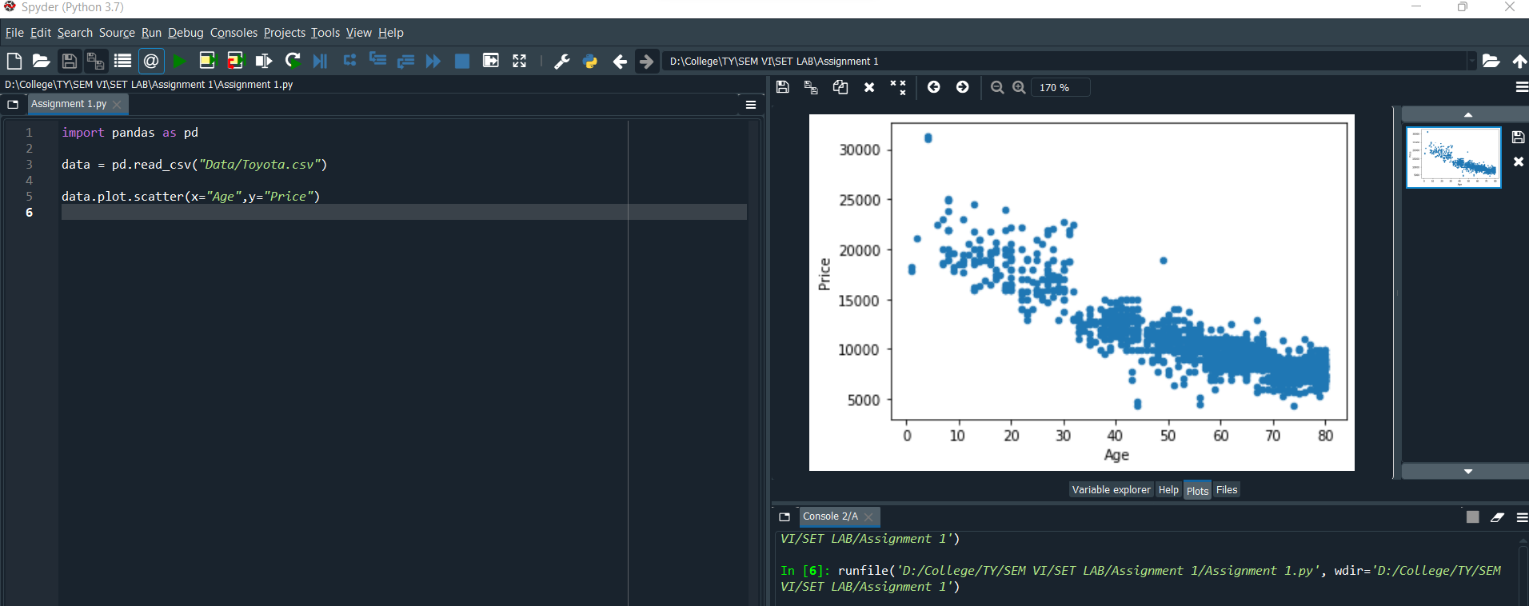

1. Histogram- for Kilometer and CC

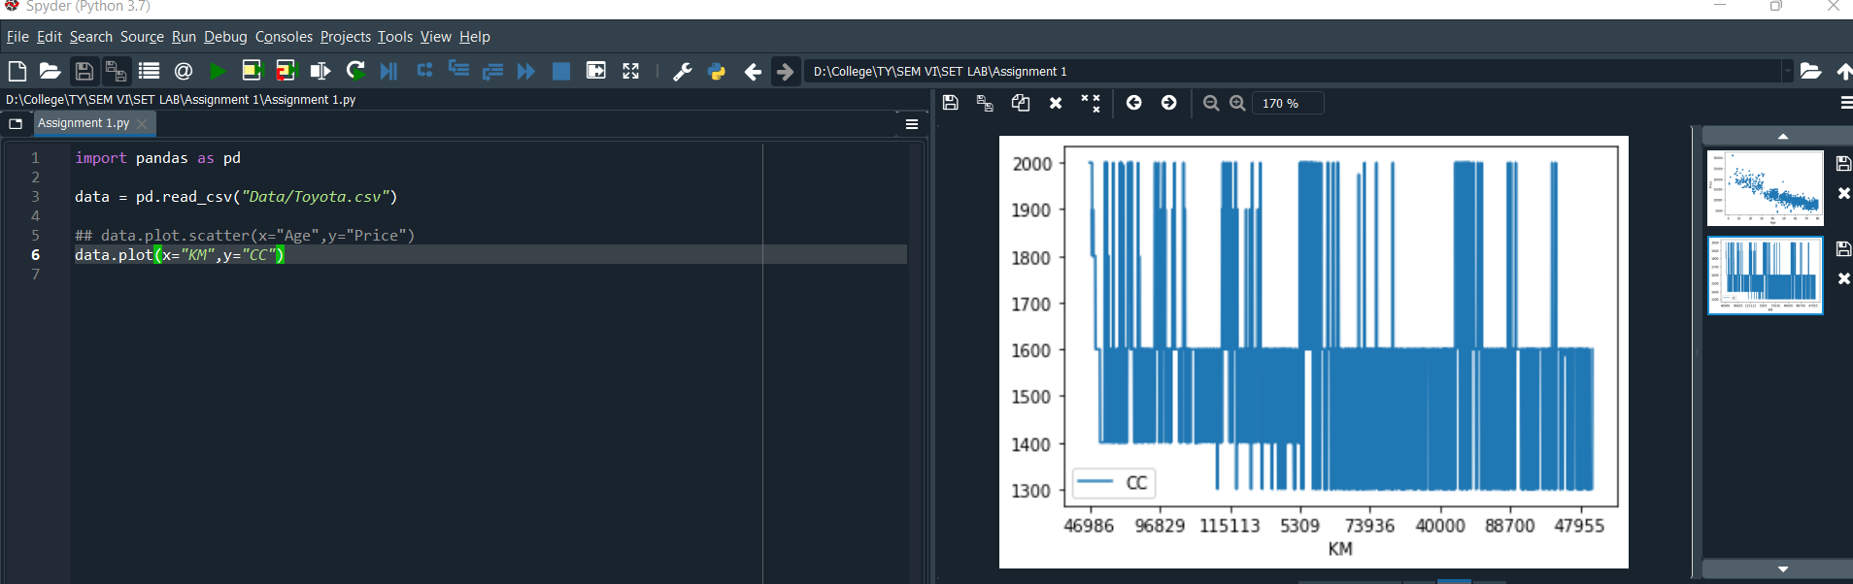

1. Bar plot- Bar plot for different fuel types

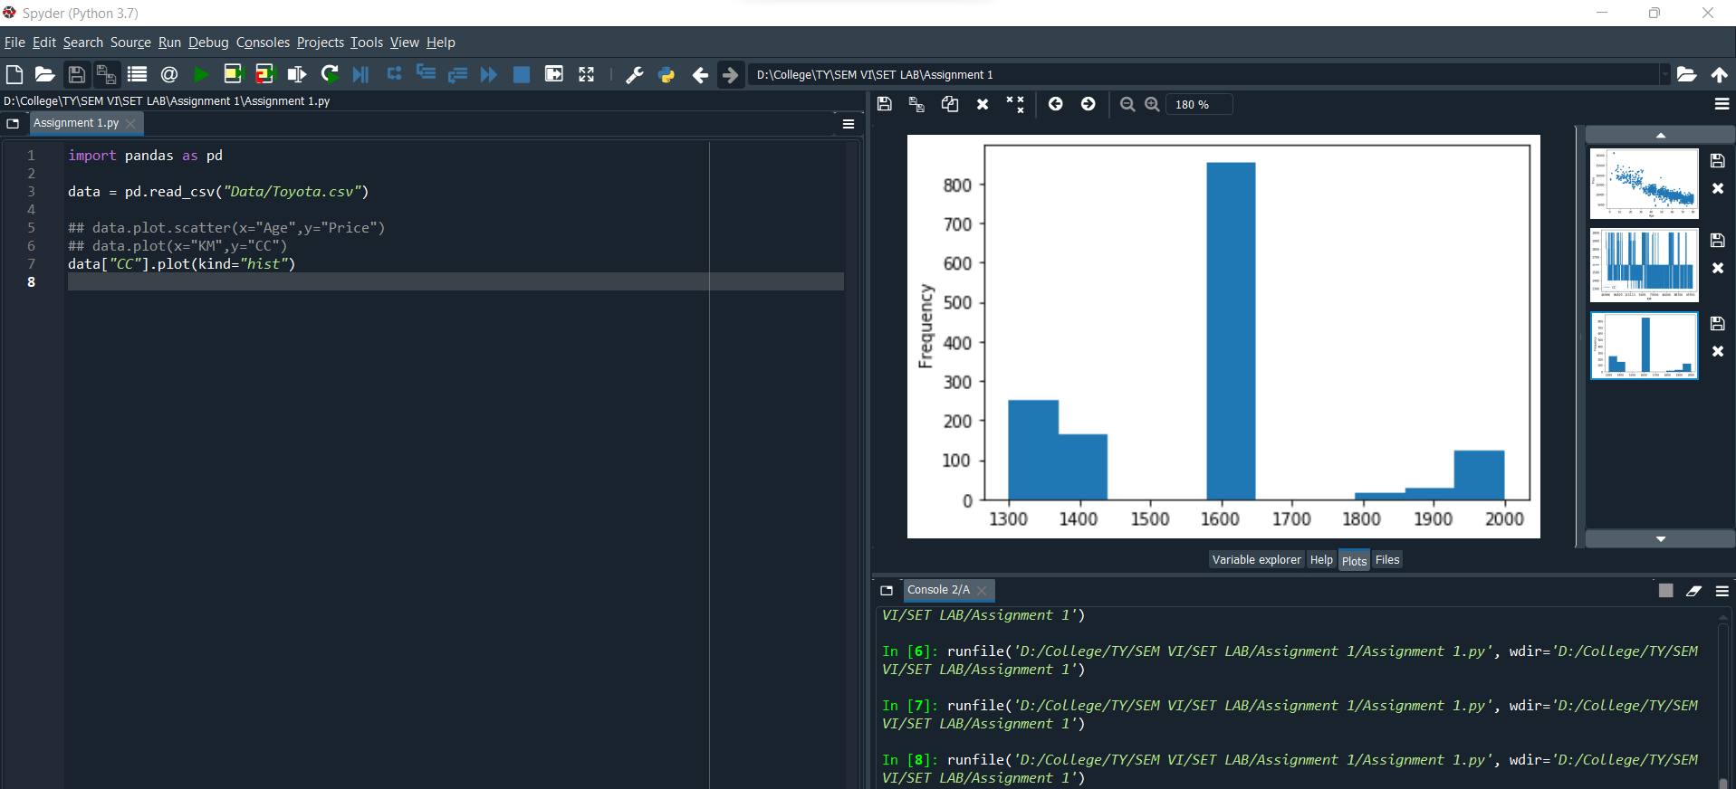

**5. Enlist some examples along with its purpose and properties (at least 10) of FOSS and proprietary software with respect to database**

FOSS:

Free and open-source software (FOSS) is a software that can be classified as both free software and open-source software.

Examples: Ubuntu, VLC Player, Android system, etc.

Advantages of FOSS:

1. Expansive licensing: Proprietary software licenses are usually quite restrictive in terms of use, number of users, type of machine and other. There is fee to own license of a proprietary software. Open-source software are free to own there is no restriction on how we use the software, we can install it on unlimited machines.

2. Transparency: Open-source development is carried out openly. As software code is openly available anyone who finds some bug can fix it for others. As development process is carried out publicly its development process is transparent. Users can easily communicate with product developers to understand their product decisions and offer opinions for betterment of software.

3. Source Code inspection: As source code is openly available anyone can view code of the software for better understanding of how the application works.

4. Source Code modification: We can also modify code after inspecting the code. One can modify code and for himself and also, he can add those changes to main version of software so that changes will be available for everyone for use.

5. Community: Foundation of open source projects is community, it includes developers of software and also users. Users in community can easily share there feedback with developers so that developers can improve the software.

6. Redistribution rights: Open-source licenses allow users to perform some changes in software and again redistribute the software without taking permission of the original product owner.

Proprietary Software:

This type of software requires licenses for their use. Company or organization that owns the software provides rights to use the software to customer. Users can only install software only on limited number of machines and cannot redistribute it.

1. Increased Functionality and Convenience

Proprietary systems are easier to use and learn, leading to faster work processes. Skype, for example, is used by organizations worldwide. It takes minutes to sign up for an account and make international phone calls or conduct video interviews online. On top of that, your customers, suppliers and employees may already have a Skype account, so they know how to use it.

Open-source programs are trickier to use and may lack user-friendly features, affecting productivity in the workplace. Unskilled end users may find it difficult to navigate them and take full advantage of what they have to offer. After all, there is a reason so few people use Linux.

2. Superior Customer Support

Open-source software can be difficult to install and set up. Customizing it isn't easier either. Plus, your staff may not be familiar with the program and may need additional training.

The average employee lacks the expertise to use open-source programs. Therefore, your team members may need help with most tasks. They will spend hours trying to figure things out instead of focusing on the tasks at hand.

Proprietary software is more accessible and includes technical support. Most companies offering these programs provide dedicated sources, 24/7 assistance, live chat and user manuals. The antivirus program Bitdefender, for example, offers online resources, technical support around the clock and security-configuration services for enterprises. If your employees experience any issues, they can simply call or email the service provider.

3. Lower Maintenance Costs

As a small-business owner, you may prefer open-source software due to its low cost. Most programs are free or cost next to nothing. The downside is that you may end up paying a lot more for setup, maintenance and customization than you'd pay with proprietary software.

Some open-source programs are difficult to install and set up, so you may need to call an expert to do the job. In some cases, new hardware may be necessary to use the software. If your employees are not familiar with the program, they will need support and training, which may further increase the costs. Updating the software, testing new versions and applying patches isn't cheap either.

4. Stronger Competitive Advantage

Proprietary technology enables organizations to be more profitable, productive and innovative. This is particularly true for software-development companies, which often use custom programs at the core of their business model.

Even if you're not a software developer, you can still benefit from using proprietary systems. For example, you may hire a team to create software programs that integrate with your existing technology. This may improve work performance and productivity in your organization, streamline business processes and increase production. Furthermore, you may customize the program and add new features as your business changes.

5. Secure Financing for Your Business

Nearly one-third of startups close their doors because they run out of capital. Developing proprietary technology doesn't guarantee success, but it could make it asier to secure financing for your small business. Plus, you will be able to charge higher prices because no other company offers the same product as you do.

As it turns out, big data investors prefer to put their money in companies selling proprietary software — or at least something other than open-source software, such as proprietary add-ons. This kind of technology isn't restricted by what already exists in the market.